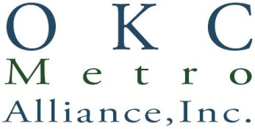
AGENDA
SPECIAL BOARD MEETING OF JANUARY 25, 2017
1940 Linwood Blvd., Oklahoma City, OK 73106
4 pm

- Roll Call and Call to Order: Susan Martin, Corporate Business Manager

- Review and Approve Lease Agreement with City of Oklahoma City: Gary Wood, President

- Review and Approve Signature Authority for Executive Director: Gary Wood, President

- Review and Approve Annual Audit: Gary Wood, President

- Old Business
- New Business
- Adjournment

