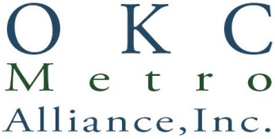

AGENDA
REGULAR BOARD MEETING OF DECEMBER 15, 2016
1940 Linwood Blvd., Oklahoma City, OK 73106
11:30 a.m.

- Introduction of Guests and Visitors: Gary Wood, President

- Roll Call and Call to Order: Susan Martin, Corporate Business Manager and President Gary Wood.

- Minutes of Regular Board Meeting, November 17, 2016: Action needed to accept the minutes.

- Financial Report: Cheryl Borelli, Secretary/Treasurer.

- Consent Docket: The Consent Docket Items as listed were sent in advance to board for review. Docket Items: PIA November 2016 Report, Men and Women’s November 2016 Report, Chief Operating Officer, November 2016 Report, and Executive Director Report. Action Required.

- Chief Operating Office Report: Suzanne Graham, COO, Jennifer Francis, Women’s Director, and Mike Cody, Men’s Director.

- Executive Director Report: Connie Schlittler

- President’s Report: Gary Wood

- Old Business

Presentation on Men’s National Housing Trust Fund Project: Allen Brown

- New Business

- Adjournment

